STAT 2040 Test 1 Review
- The in-class test is a closed-book, closed-notes assessment and is scheduled for next Monday. The in-class Test 1 will include material from Chapter 1 to the content covered in Chapter 3.
- Test 1 will include both multiple-choice and open-ended questions.
- Complete the sample problems below and submit them by Saturday, at 11:59pm to receive an extra 2 points on your test. The answer key for the sample questions will be available Sunday.
- Formulas provided in the test:
$$IQR=Q_{3}-Q_{1}$$
$$lower fence=Q_{1}-1.5×IQR$$
$$upper fence=Q_{3}+1.5×IQR$$
$z=\frac{(x-μ)}{σ}$, $s=\sqrt{\frac{\sum_{i=1}^{n}{{(x-\overline{x})}^{2}}}{n-1}}$

- A survey of radio stations was conducted following the attacks on the World Trade Center in 2001. One of the variables recorded was the region in which the station was located (east, center, or west). The variable “region” is:
 | a. | quantitative, because region is not a number.
 | b. | quantitative, because region is a number.
 | c. | categorical, because region is not a number.
 | d. | categorical, because region is a number.
- The following is a histogram showing the distribution per year of the cumulative property damage caused by tornadoes, over the period 1950 to 1999, in each of the 50 states and Puerto Rico. The data are in millions of dollars, and the class intervals are 0 to < 10, 10 to < 20, and so forth.
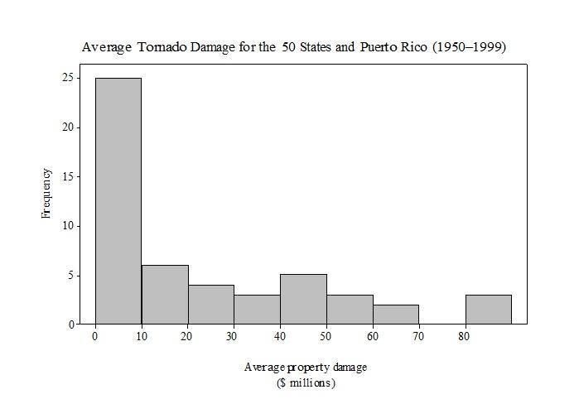

- Select the statement to describe the shape and center of the distribution of average tornado damage.

a. The distribution is left-skewed, with a center of about $10 million dollars.
b. The distribution is right-skewed, with a center of about $10 million dollars.
c. The distribution is left-skewed, with a center of about $40 million dollars.
d. The distribution is right-skewed, with a center of about $40 million dollars.

- Select the statement explaining whether $\overline{x}$ and $s$ would be useful for describing the distribution of average tornado damage.

- $\overline{x}$ and $s$ are useful descriptions of center and spread for any type of distribution.
- $\overline{x}$ is useful but $s$ is not because the data indicates a graph with one peak.
- $\overline{x}$ and $s$ would not be very useful because the data is heavily skewed.
- $\overline{x}$ and $s$ would be useful because the data is approximately symmetric

3. Birth weights of infants at a local hospital have a normal distribution, with a mean of 110 oz and a standard deviation of 15 oz. Using the 95 rule, 95% all infants have birth weights between what two values?
a. 110 oz and 115 oz b. 95 oz and 115 oz c. 65 oz and 155 oz d. 80 oz and 140 oz
4. The following list of numbers shows the values of a variable X for a data set: 82, 56, and 78.
Complete the following table and use your results to find the sample standard deviation.
Observation, x | Deviation ($x-\overline{x})$ | Squared deviation (${(x-\overline{x})}^{2})$
82 | 82-72 =10 | 10^2=100
56 | 56-72=-16 | -16^2=256
78 | 78-72=6 | 6^2=36
Total | 0 | 392

Sample Standard deviation $s= _____14_________________$.
Use R to compute standard deviation for the data set: ___around 14___________________
- Consider the boxplot summarizing weight of a group of children (4–5-year-old) in the kindergarten.
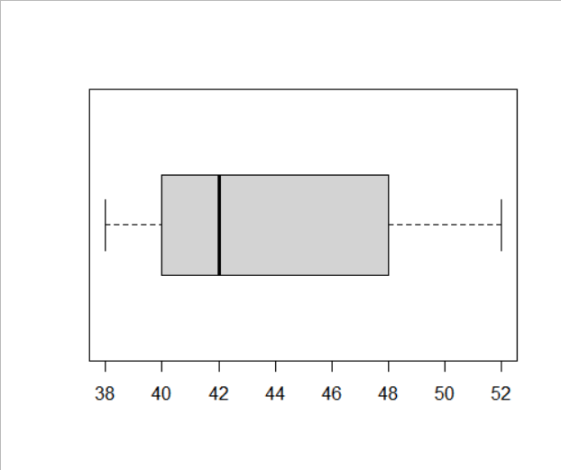

  - 25% of children are weighted more than how many pounds? Around 42
  - What percent of children are between 40 and 48 pounds? 50 percent
  - What value of weight is exceeded by 75% of children’s weights? 50 and more

6. A survey of 10 students was conducted to investigate the amount of time they spend on social media each day. Students were given a timer and asked to record the number of minutes spent every time they accessed social media. The students’ total times for one day are given below (in minutes).
105 117 57 63 79 84 92 99 170
a. Find the 5-number summary and the interquartile range ($IQR=Q_{3}-Q_{1}$) 57, 71, 92, 102, 170 IQR = 31

b. Find both the lower ($Q_{1}-1.5×IQR$ ) and upper ($Q_{3}+1.5×IQR$ ) fences. Identify any outliers.
Lower fence is 24.5, upper is 148.5, outliers is 57 and 170

7. The final scores of STAT 1040 for 280 students are summarized in the histogram below. The horizontal indicates the variable of score and the vertical indicates the number of students.
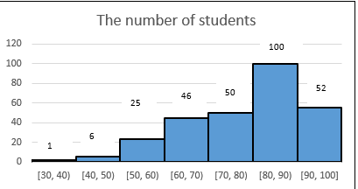

- To describe the shape of the distribution for the final scores of STAT 1040, circle all that apply.

i. Skewed right, ii. Bimodal iii. Unimodal iv. Symmetric v. Skewed left

- Which of the following statements are true:
i. mean score > median score
ii. mean score < median score
iii. mean score is approximately equal to the median score
8. Suppose you were enrolled in three classes last semester, statistics, geometry, and algebra II. You received a grade of 82 on your statistics exam, where the mean grade was 72 and the standard deviation was 10. You received a grade of 74 on your geometry exam, where the mean grade was 60 and the standard deviation was 12. Finally, you received a grade of 91 on your algebra II exam, where the mean grade was 88 and the standard deviation was 6. Although your highest test score was 91 (computer), in what classes were your scores the best and worst relative to the rest of the classes? respectively. Best Geometry, worse alegrbra 2

9. A veterinarian is interested in studying the causes of enteroliths (stones that form in the gut of horses). An observational study comparing the diet of horses admitted to the veterinary hospital with enteroliths and the diet of horses admitted for other reasons does not allow causal conclusions to be drawn because:
  - an observational study can only establish correlations, unless the investigator is double blinded.
  - associations in observational studies can be confounded by lurking variables.
  - the study does not match horses.
  - All of the answer options are correct.

10. An educator wishes to study the effects of sleep deprivation on the ability to concentrate. He decides to study the students in a calculus class. After consultation with a statistician, the educator decides to randomly allocate students to either a group that will sleep for 8 hours the night before class or 6 hours. The educator does not know which group a student belongs to when she or he comes to class. The educator, after talking to some students and before the experiment, decides that the number of classes students have on the same day before calculus could potentially confound the study and wishes to make an adjustment. The design that allows for such an adjustment is called:

- a randomized block design. c. a double-blinded design.
- a placebo controlled completely randomized design. d. a matched block design.

11. A memory experiment was conducted to assess whether the length of the list had a significant effect on the percentage of words recalled. There were three list lengths: 10 words (short), 20 words (medium), and 40 words (long). Since the researcher was concerned that age of the subject could affect percentage of words recalled, she first divided the subjects into three age groups. Then in each age group, subjects were randomly assigned to one of the three list lengths. The percentage of words recalled for each subject was recorded and compared between the list lengths.

  - The response variable in this study is
    - List length
    - Percentage of words recalled
    - Age of the subjects

  - The explanatory variable in this study is
    - List length
    - Percentage of words recalled
    - Age of the subjects

  - A confounding variable the researchers try to control for is
    - List length
    - Percentage of words recalled
    - Age of the subjects
  - The design that allows for such an adjustment is called:
    - a randomized block design.
    - a double-blinded design.
    - a placebo controlled completely randomized design.
    - a matched block design

12. Advice columnist Ann Landers once asked her readers with children to answer the following question: “If you had it to do over again, would you have children?” Readers were invited to send a response to this question by mail. Of the approximately 10,000 responses Landers received, approximately 70% said “no.” The sample:
- is probably representative of all parents.
- may suffer from response bias, because people who feel very strongly about this issue are more likely to respond than people who do not.
- has little bias, because more than 10,000 people responded, yielding a very large sample.
- is probably not representative, because more than 10,000 people responded.
13. Apparently, according to some studies, men who drive expensive sports cars have lower blood pressure and fewer cardiovascular health problems. We can’t conclude that driving expensive sports cars lowers blood pressure or improves cardiovascular health because the studies described are clearly:
- experiments.
- observational studies, not experiments—lurking variables may explain the association.
- paired data experiments.
- stratified experiments.

14. A researcher studying the effect of price cuts on consumers’ expectations makes up two different histories of the store price of a hypothetical brand of laundry detergent for the past year. Eight students in a business class view one or the other price history on a computer. Some students see a steady price, whereas others see regular sales that temporarily cut the price. Students are asked the price they would expect to pay. This is an example of:
- a matched pairs experiment.
- a two-factor design.
- a completely randomized experiment.
- a randomized observational study.

15. A study attempts to compare two sunscreens. Each of 50 subjects with varying skin complexions will use both sunscreens—Screen A on one side of the body and Screen B on the other side. For each subject, a coin is tossed to determine which side receives Screen A and which receives Screen B. Researchers measure the amount of ultraviolet light exposure over both treated areas for each subject and compare. The researchers found that skin areas treated with sunscreen A had 55% more ultraviolet light exposure than skin areas treated with sunscreen B.
a. Is this an
i. Observational Study
ii. Randomized Controlled Experiment
iii. Matched Pairs Experiment

b. What is the explanatory variable?
i. Sunscreen: A / B
ii. Amount of ultraviolet light exposure

c. What is the response variable?
i. Sunscreen: A / B
ii. Amount of ultraviolet light exposure

d. Can we conclude that there is a causal relationship between type of sunscreen and ultraviolet light exposure?
i. Yes.
ii. No.

e. Are confounding variables likely?
i. Yes
ii. No

16. Scores on an exam (out of 100 points) given in a large introductory statistics course are displayed in the provided histogram.
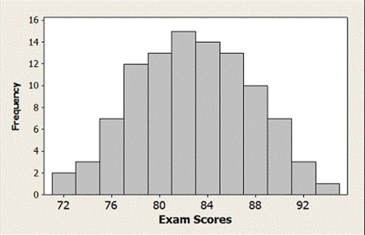
a. Based on the histogram, which value is likely the mean exam score?
i. 82 ii. 88 iii. 76 iv. 92

b. Based on the histogram, the standard deviation of the exam scores is likely closest to which of these values?
i. 0.5 ii. 1 iii. 5 iv. 10

17. A health-and-wellness researcher wishes to determine whether there is a relationship between the gender of an individual and the amount of alcohol consumed. A sample of 68 people is selected, and individuals are classified by gender and alcohol consumption (low, moderate, high).

Low Moderate High
Male 10 9 8
Female 13 16 12

Which of the following are true:
a. Men are more likely than women to consume alcohol in moderate amounts.
b. There is no difference in alcohol consumption between males and females.
c. Men are more likely than women to consume alcohol in low amounts.
d. Women are more likely than men to consume alcohol in low amounts.

18. A school administrator takes a random sample of 100 high school students and find that 13 or (13%) have tried vaping. Unbeknownst to the administrator, 20% of all high school students have tried vaping.
A. In this situation,
  - 13% is a parameter and 20% is a statistic.
  - 20% is a parameter and 13% is a statistic.
  - both 13% and 20% are parameters.
  - both 13% and 20% are statistics.
  - 20% is an estimate and 13% is a margin of error.
B. Give two notations for the numbers in the answer you selected from part A. statistic the sample can be shown as p hat so p hat is 0.13, parameter the population is p so p is equal to 0.20

19. Suppose that a student is working on a statistics project using data on pulse rates collected from a random sample of 100 students from her college. She finds a 95% confidence interval for mean pulse rate to be (65.5, 71.8). Discuss how each of the statements below would indicate an improper interpretation of this interval.

- I am 95% sure that all students will have pulse rates between 65.5 and 71.8 beats per minute.
- I am 95% sure that the mean pulse rate for this sample of students will fall between 65.5 and 71.8 beats per minute.
- I am 95% sure that the confidence interval for the average pulse rate of all students at this college goes from 65.5 to 71.8 beats per minute.
- I am sure that 95% of all students at this college will have pulse rates between 65.5 and 71.8 beats per minute.
- I am 95% sure that the mean pulse rate for all US college students is between 65.5 and 71.8 beats per minute.
- Of the mean pulse rates for students at this college, 95% will fall between 65.5 and 71.8 beats per minute.
- Of random samples of this size taken from students at this college, 95% will have mean pulse rates between 65.5 and 71.8 beats per minute.

20. Use the bootstrap distributions in Figure below to estimate the value of the sample statistic and the standard error, and then use this information to give a 95% confidence interval. In addition, give notation for the parameter being estimated. N/A
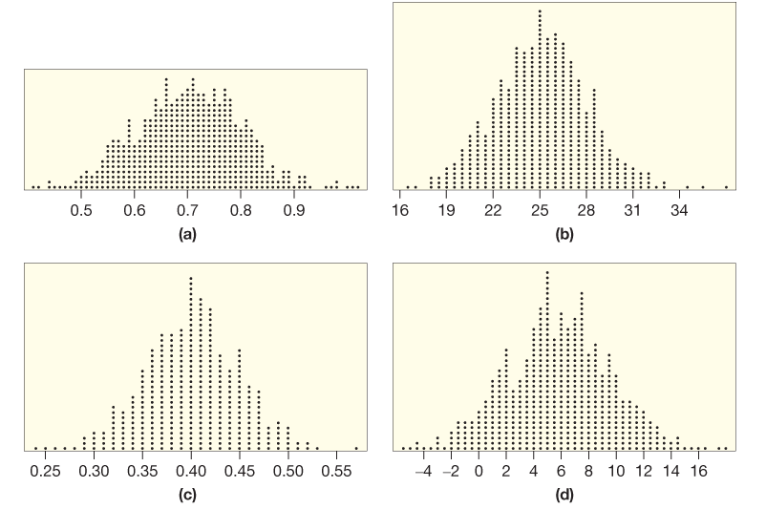

21. A type of small snail is very widespread in Japan, and colonies of the snails that are genetically similar have been found very far apart. Scientists wondered how the snails could travel such long distances. A recent study43 provides the answer. Biologist Shinichiro Wada fed 174 live snails to birds and found that 26 of the snails were excreted live out the other end. The snails apparently are able to seal their shells shut to keep the digestive fluids from getting in.

a. What is the best estimate for the proportion of all snails of this type to live after being eaten by a bird? 14.94 percent based on the finding p hat of 26 divided by 0.1494

b. Figure below shows a bootstrap distribution based on this sample. Estimate the standard error. Using the data from the other sample the standard deviation is 0.0271 but with the below data it says the st is 0.028 so there are close
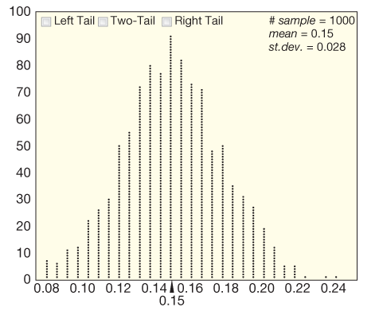
- Use the standard error from part (b) to find and interpret a 95% confidence interval for the proportion of all snails of this type to live after being eaten by a bird. The standard error taking what we calculated would be (0.0963, 0.2025) or (9.63%, 20.25%).

d. Using your answer to part (c), is it plausible that 20% of all snails of this type live after being eaten by a bird?
Yes it plausible that 20 percent survive due to 20 percent lies within the interval

